عنوان البحث والمحتوى الصفحة الحالية يكتب بخط نوع Arial (Body CS) وبحجم 18
الاطار أعلاه يمكن تغيرة حسب الكلية لوضع اسم الكلية وشعارها ضمن الفورمة المخصصة للبحث

RESEARCH PROJECT TITLE

The Graduation Research Submitted to

The Conical of the collge of ………...
National University of Science and Technology
Requrment for the degree of Bachalor in ………

By
XXXXX
XXXXX
XXXXX
يتم كتابة أسماء الطلبة المنجزين للبحث

Superviser
Prof. Dr. Name
Write Islamic date
Write Gregorian date

ABSTRACT

Bachalor Resarch Research project
اللغة الإنجليزية للقسم:

قسم …………………

يجب أن تكتب كـالتالي
THE TITLE OF THE RESEARCH PROJECT

Student Names in English
XXXX
XXXX
XXXX
National University of Scince and Technology
Golloge of XXXX
يجب ان تكون كتابة مضمون البحث باللغة الإنكليزية بخط نوع Times New Roman وبحجم 12 عادي
Department of XXXX
يجب مراعات كتابة اللقب العلمي الصحيح للتدريسي المشرف على البحث

Research Advisor:
EX: Prof. Dr. AHMED ALI MOHAMMED
Date and pages: EX: January 2016, 38 pages

In this study, AISI 304 (X5CrNi1810) type austenitic stainless-steel sheets were joined with TIG welding method under different protective media. The welding processes were carried using pure argon, argon+%1,5 H₂ and argon+% 5 H₂ as shielding media at three different welding currents. Both butt welding and overlap joining processes were performed at the same welding parameters using ER 308 L as filler metal wire. In order to determine the strength of the welded joints, tensile, bending, notch stroke and fatigue tests were applied. In addition, hardness and optical microscope studies of the welded samples on the welding areas were done.
As a result of the hardness tests, the highest hardness values were measured on the welding metal and these are followed by AUHI and base material. The tensile test results showed that the highest tensile strengths for the both types of joining
processes were obtained under argon + %1,5 H₂. Fatigue performance of the main metal was found to be better than both butt and overlap joints. In addition, addition of H₂ gas into argon was considered to decrease the fatigue performance of the welded joints. As a result of the notch stroke tests, toughness values measured on the all samples were determined to be smaller than base metal. Visual examination of the bending tests carried out up to 180º showed no failures such as crack, tear etc. on the welded specimens. Consequently, it was realised that, protective gas mixture used during welding influenced the microstructures of the welding metal.

Key Word : Stainless steel, TIG welding, gas mixture, microstructure, fatigue and mechanical properties.
Science Code : 701.3.019

CONTENTS
يجب إضافة بيان الصفحة إلى الأقسام التي تحتوي على أرقام الصفحات في جدول المحتويات وفهرس الأشكال وفهرس الجداول.
يجب إنشاء قسم المحتويات بمسافة 1.5 سطر (بدون مسافات إضافية قبل وبعد) وتركه مضبوطًا. يمكن إنشاء هذا الدليل تلقائيًا أو يدويًا. ومع ذلك ، يجب إنشاء النقاط التي تؤدي إلى رقم الصفحة باستخدام "علامة التبويب اليمنى المنقطة" ، وليس بالضغط على مفتاح "النقطة".
Pages
ABSTRACT ii
CONTENTS iv
INDEX OF FIGURES v
INDEX OF TABLES vi
INDEX OF SYMBOLS AND ABBREVIATIONS vii
Chapter 1 1
Introdection 1
Chapter 2 4
CHAPTER TITLE. EX: STAINLESS STEELS 4
2.1. STAINLESS STEEL TYPES 5
2.1.1. Ferritic Stainless Steels 6
2.1.2. Austenitic Stainless Steels 8
2.1.2.1. Weldability of Austenitic Stainless Steels 9
Chapter 3 11
FATIGUE IN METALS 11
3.1. FACTORS AFFECTING FAILURE 11
3.1.1. Piece Size 11
3.1.2. Surface Condition 11
3.2. TYPES OF FATIGUE 12
3.2.1. Thermal Fatigue 12
3.2.2. Corrosion Fatigue 12
Chapter 4 13
EXPERIMENTAL RESULTS AND DISCUSSION 13
4.1. HARDNESS TEST 13
4.2. NOTCH IMPACT EXPERIMENT 14
4.3. FAILURE EXPERIMENT 15
4.4. MICROSTRUCTURAL STUDIES 18
Chapter 5 20
RESULTS 20
REFERENCES 22
APPENDICES 23

INDEX OF FIGURES
Pages
Figure 2.1. Nickel and chromium amounts for different types of stainless steel 7
يجب محاذاة الأحرف الأولى من نص الشكل. (باستثناء ملحق الشكل)

قم بإجراء المحاذاة باستخدام مفتاح "TAB". ليس مع "الفضاء".
Figure 4.1. Hardness measurement results. 13
Figure 4.2. Notch impact test results of base metal and butt welded samples. 14
Figure 4.3. Fatigue strength of butt welded specimens and base material in pure argon atmosphere. 16
Figure 4.4 Fatigue strength of butt-welded samples using base material and argon + 1.5% H2 gas. 16
Figure 4.5.Ana malzeme ve üç değişik gaz atmosferi ile (saf argon, argon +%1,5 H2 ve argon + % 5 H2) 18
Figure 4.6. Microstructure image of the sample combined under pure argon shielding gas. 19
Figure A.1. Notch impact test results of base metal and butt welded samples. 20

إذا كان التعليق التوضيحي يتكون من سطرين ، فيجب إنشاؤه بمسافة سطر واحد ومسافة 6 نقاط بعده. يجب أن يستمر السطر الثاني مضبوطًا إلى اليسار. (من حيث يشير السهم)

INDEX OF TABLES
تنطبق كل قاعدة في فهرس الأرقام هنا أيضًا.
يجب إنشاء قسم TABLES INDEX بمسافة 1.5 سطر (بدون مسافات إضافية قبل وبعد) وضبط اليسار. يمكن إنشاء هذا الدليل تلقائيًا أو يدويًا.
ومع ذلك ، يجب إنشاء النقاط التي تؤدي إلى رقم الصفحة باستخدام "علامة التبويب اليمنى المنقطة" ، وليس بالضغط على مفتاح "النقطة".

تنطبق هنا أيضًا جميع التصحيحات والقواعد الواردة في فهرس الأرقام.
Pages
Table 2.1. Physical properties of stainless steel groups 7
Table 4.1. Sample group and properties. 15
Table A.1. Reasearch project materials and tools Tables. 23

INDEX OF SYMBOLS AND ABBREVIATIONS
يجب ان يكون ترتيب Symbols ابجديا وحسبةحروف اللغة الإنكليزية. في حال وجود رموز علمية ضمن الجدول فيجب ان تكون في نهاية الجدول وكما موضح ادناه

SYMBOLS
Ag : silver
Al : aluminum
Ar : argon
Au : gold
Cr_{eş} : chromium equivalence
Cu : Copper
erf(z) : error function
H₂ : hydrogen
He : helyum
Mo : molybdenum
Ni : nikel
Ni_{eş} : nickel equivalence
: normal stress
: polar angle
: unit volume weight
(x) : gamma function
c : uniaxial compressive strength

يجب محاذاة أحرف النقطتين (:) والحروف الأولى من الرموز. قم بإجراء المحاذاة باستخدام مفتاح "TAB". ليس مع "ازر المسافة".
كذلك يجب ان يكتب اسم الرمز العلمي باللغة الإنكليزية بالأحرف الصغيرة كاملا

ABBREVIATIONS
في توسيع الاختصار، يجب كتابة الحرف الأول من كل كلمة بالحرف الكبير
يجب أن تكون أحرف الاختصار كبيرة.
إذا كان عدد الرموز والاختصارات صغيرًا، فيمكن تقديمها في نفس الصفحة. تخصص هذه الصفحة للمختصرات العلمية الأساسية المستخدمة بالبحث وكما موضح ادناه ويجب ان تكون الكتابة باللغة الإنكليزية.

AISI : American Iron and Steel Institute
ASTM : American Society for Testing and Materials
AUHI : Area Under Heat Influence
AWS : American Welding Society
DIN : Deutch Industrie Normen
EN : European Norm
IIW : International Institute of Welding

Chapter 1
يكون اسم الفصل بخط نوع SimSun وبحجم 18 من نوع Bold الحرف الأول كبير فقط من كلمة Chapter
يكون عنوان الفصل بخط نوع
Times New Roman وبحجم 12 من نوع Bold
يجب إعطاء كل فصل جديد مع رقم الفصل ويجب كتابة عنوان عام يصف الفصل بمسافة فقرة واحدة بينهما.

Introdection

Stainless steels are preferred mainly because of their excellent corrosion resistance. Steels with at least 12% chromium in their composition are called “stainless steel”. The corrosion resistance of all stainless steels is based on the formation of a very dense and protective layer of chromium oxide (thin passive surface). The meaning of this mechanism that provides protection against corrosion is; When the passive layer on the surface of the steel is broken, the steel is locally corrosive, and corrosion of the metal continues in the region that becomes active in this way. Therefore, localized corrosion types such as pitting and crevice corrosion, stress and grain boundary corrosion are generally more critical than general corrosion. For these reasons, some alloying elements added to steel provide a very effective resistance to local attacks. Resistance to pitting and crevice corrosion is enhanced by the contents of Cr, Mo, Ni in the form of solid solutions. Stainless steels are generally collected in five main groups: These are; ferritic stainless steels, martensitic stainless steels, dual-phase (duplex) stainless steels, precipitation hardening stainless steels, and austenitic stainless steels.
Austenitic stainless steels are one of the most widely used in the stainless-steel family. They have a wide application area in the food, pharmacy, chemistry and petrochemical fields in the industry. AISI 304 and AISI 316 are the most important of the austenitic stainless steels. 304 contains 18% chromium and 10% nickel, and such stainless steels show excellent corrosion resistance. 316 is an austenitic stainless-steel type containing 17% chromium, 12% nickel and 2.2% molybdenum in its composition, and it finds use in much more severe corrosive environments such as chloride environments where 304 is insufficient. One of the other important features of austenitic stainless steels is that they do not have magnetic properties, unlike those usually seen in steels.
من هذه الصفحة، يجب أن يبدأ ترقيم الصفحات من 1 ويستمر حتى نهاية الرسالة.
All welding methods used for other steels (except oxy-gas welding) are used for stainless steels, with some limitations. Stainless steels can be welded by electric arc welding, MIG welding, TIG welding, submerged arc welding, plasma arc welding and laser beam welding. Today, the most common welding method for joining stainless steels is TIG welding.
TIG welding; It is a welding method where the heat energy required for welding is provided by the arc created between a tungsten electrode and the workpiece, and the welding area is protected by an inert gas sent from a nozzle surrounding the electrode. In this welding method, high quality smooth surface and perfect welding seams can be obtained. TIG welding method gives perfect weld seams when welding stainless steel materials.

Argon is often used as the shielding gas in TIG welding of austenitic stainless steels. Commercial gas mixtures (argon-hydrogen) can also be used to increase the welding speed when welding austenitic stainless steels. The non-melting tungsten electrode is connected to the (-) pole and welded with direct current. This method is suAUHIle for all welding positions and especially for thin sheets and root passes.
The aim of this study is to combine AISI 304 quality austenitic stainless steel materials, which are of great importance in the industry, by TIG welding method using different shielding gases (pure argon, argon + 1.5% H2 and argon + 5% H2), to determine the weld ability, microstructure and mechanical properties. research and examination.
This study is generally composed of two parts: literature review and experimental studies. However, literature review and experimental studies have been tried to be formed under three headings in themselves. The first part of these is “Introduction” and a brief summary of the study is given here. In the second part, the stainless steels used in this study, including the austenitic stainless steels, are explained with a wide literature review. In the third chapter, the TIG welding method used in the welding of austenitic stainless steels used in this study is introduced in detail. In the fourth chapter, which is the last part of the literature review, fatigue in metals, factors affecting fatigue, fatigue types and fatigue in welded joints are explained.
In the fifth chapter, besides determining the purpose of the study, the materials used in the experimental studies, the additional metal used, the welding machine, the welding parameters, the extraction of the test samples from the welded samples, the mechanical tests applied to the welded joints and the application parameters of the tests are introduced.
In the sixth part of the study, the data obtained from the mechanical tests applied to the welded samples were drawn graphically for easy evaluation and the obtained graphics were evaluated. In addition, the images obtained as a result of optical microscope studies were interpreted. The findings obtained as a result of experimental studies were compared with similar studies conducted before, with a cause-effect relationship.
In the seventh and last chapter, where the final results of the experimental studies are explained, the findings obtained as a result of the experimental studies are interpreted and concluded in accordance with the purpose of the experimental study.

Chapter 2
عادة مايكون الفصل الثاني من البحث مختص بالدراسات السابقة التي تتعلق ببحث الطالب الحالي
يكون عنوان الفصل بخط نوع
Times New Roman وبحجم 12 من نوع Bold
يكون اسم الفصل بخط نوع SimSun وبحجم 18 من نوع Bold

CHAPTER TITLE. EX: STAINLESS STEELS

Stainless steels, which are among the indispensable materials of today's industry, are mainly alloys containing iron, carbon and often nickel and owe their main properties to chromium. The main reason why the application areas of stainless steels, which are a type developed to increase the corrosion resistance of iron alloys, continue to increase day by day is their high corrosion resistance in corrosive environments without losing their mechanical properties. Stainless steel must contain at least 12% Cr in order to be rustproof [1].
يجب ترقيم المراجع المرقمة بين قوسين معقوفين.

Goto According to the study of Goto et al. in 1975, only metals such as gold and platinum are found in nature in pure form, while normal metals are combined with other elements. Rusting is therefore a natural phenomenon. Iron, which is found in nature in the form of iron ore, is therefore unstable and wants to rust. A layer of rust forms on carbon steel that does not have any protective coating and protects the rest of the steel. If the rust layer on the surface is removed, a new rust layer is formed. This condition is called rusting. Painting, zinc coating (galvanizing), various coatings with epoxy resins delay or stop the rusting process [2].
لا ينبغي أن تكون المراجع المؤلف (السنة) في المراجع المرقمة.

بما أن لغة الأطروحة هي اللغة الإنكليزية وآخرون. يجب استخدامها.

انظر التفسيرات الإضافية ب للحصول على الاستشهادات في المراجع الأبجدية.
يجب أن تستمر المراجع بأرقام متتالية.
Chromium in stainless steel has a great affinity for oxygen. When chromium encounters oxygen, a molecular level chromium oxide film forms on the surface of the steel. The thickness of this film is 130 Angstroms. This is like protecting a large building from rain with a sheet of paper thick roofing sheet [2].
The common feature in iron-based alloys and other technologically important alloys is the oxidation of both solvent and solvent atoms. Wagner studied the oxidation of alloys in two categories: (1) noble (unchangeable elements, such as Pt, Ag, and Au) and alloying element (such as Pt-Ni), and (2) non-noble principal element and non-noble alloying elements. Fe-based alloys, Fe-Cr, Fe-Si, Fe-Cr-Al, Fe-Ni-Cr and Fe-Cu alloys fall into this second category.
According to Goto et al. 1942, the purpose of forming a protective layer is to protect the alloy against oxidation, especially at high temperatures. The desired properties of the protective layer are to be stable at the desired temperature and oxygen partial pressures, to grow very slowly, that is, to have low parabolic velocities. The oxides that provide this are SiO2, Cr2O3 and Al2O3 [3].
P_Stainless steels are not the discovery of recent years. Faraday showed in 1822 that when chromium is added to iron, an alloy that is highly resistant to atmospheric oxidation is formed. In 1838, Mallet discovered that chromium steels showed corrosion resistant properties in some environments. Until the end of the 19th century, chromium steels were used only for hot sulfuric acid containers. In 1904, Monnartz demonstrated that the passivation property of chromium added steels became more pronounced in oxidizing environments. He proved that the corrosion resistance of these metals is due to the passive layer formed on the metal surface. However, the formation of a passive film is not sufficient for alloys to be resistant to corrosion in all environments. One of the ways to make stainless steels more resistant to the environment is to increase the ratio of main alloying elements such as chromium and nickel and to reduce the carbon content [4].
في ترقيم العناوين، يجب وضع مسافة بعد النقطة.

حتى لو تم عمل العناوين باستخدام الترقيم التلقائي، يجب أن تكون المسافة هي الحد الأقصى. علما ان حجم الخط 12
يجب أن تكون عناوين المستوى 2 غامقة ويجب كتابة جميع أحرف الكلمات بحروف كبيرة، ويجب أن تكون هناك نقطة بين ترقيم العناوين وفي نهايته.

2.1. STAINLESS STEEL TYPES

In stainless steels, alloys with different properties can be obtained by changing the chemical composition. Corrosion resistance can be increased by increasing the amount of chromium or adding alloying elements such as nickel and molybdenum. In addition, additional positive effects can be achieved by alloying with some elements such as copper, titanium, aluminum, silicon, niobium and selenium. The most important alloying elements determining the internal structure of stainless steels are chromium, nickel, molybdenum and manganese, in order of importance. First of all, chromium and nickel determine whether the microstructure is ferritic or austenitic (Figure 2.1).
إذا كان العنوان يتكون من سطرين على الأقل، فيجب كتابته بشكل مبرر على كلا الجانبين وبمسافة 1.5 سطر.
Paslanmaz çelikler beş ana grupta toplanırlar:
عند الاستشهاد بالأرقام، لا ينبغي استخدام الفترات في نهاية الترقيم. مثال: الشكل 2.1
- Ferritic stainless steels
يجب استخدام نوع واحد فقط من اشكال التعداد في البحث باكمله.

يجب وضع مسافة بادئة للأشياء بمقدار 0.5 سم من اليسار.
- Martensitic stainless steels
- Austenitic-Ferritic (Bi-Phase) stainless steels
- Precipitation hardening stainless steels
- Austenitic stainless steels [5].
يجب أن يكون الحرف الأول من كل كلمة كبيرًا وأن تكون الأحرف الأخرى صغيرة ، كما يجب أن تكون هناك نقطة بين ترقيم العنوان وفي نهايته.

2.1.1. Ferritic Stainless Steels

Ferritic stainless steels contain 16-30% Cr depending on the amount of alloying elements, especially carbon, they are magnetic, they can be rolled cold or hot [1].
في الأجزاء التالية من البحث ، يمكن الاستشهاد بالمصادر السابقة مرة أخرى.

Ferritic stainless steels are ferrite at room temperature. These alloys are magnetic at room temperature and retain these properties up to the Curie temperature (768 °C). Stainless steels in this group contain 12-30% Cr. They do not contain nickel. In addition, the carbon ratio is very low, such as 0.02 to 0.12 percent. Ferritic stainless steels with 12% Cr; It provides low cost production and good corrosion resistance. Sufficient amounts of chromium and other alloying elements are needed to stabilize the ferrite completely in these steels. Carbon, which is thought to expand the γ (Gamma) region, needs to be kept at very low rates. In this way, while maintaining high toughness and ductility, austenite transformation is prevented. Heat-treated stainless steels have a multi-grain and single-phase microstructure. In order to prevent the formation of harmful phases affecting the drawability and toughness, the alloyed ferritic grains should be cooled rapidly after homogenization heat treatment at high temperature (at 1100 °C) [6]. In Figure 2.1, the amounts of chromium and nickel for different types of stainless steel are given.
عند الاستشهاد بالأرقام ، لا ينبغي استخدام الفترات في نهاية الترقيم. مثال: الشكل 2.1
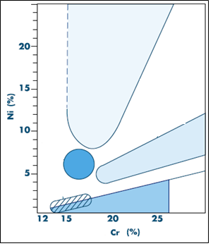
- يجب تضييق جميع الأشكال والجداول في الرسالة بحيث لا تتجاوز مساحة استخدام الصفحة (4 سم من اليسار و 2.5 سم من اليمين).
- في جميع الأشكال والجداول ، يجب أن يكون الحرف الأول من الكلمة الأولى كبيرًا وأن تكون جميع الأحرف الأخرى صغيرة. (باستثناء أسماء العلم).
- يجب أن تكون هناك فترة بين ترقيم الأشكال والجداول وفي نهايتها. الشكل 2.1. الجدول 4.17. مثل…
- إذا كانت نصوص الأشكال والجدول تتكون من سطر واحد ، فيجب توسيطها ، وإذا كانت تتكون من المزيد من الأسطر ، فيجب كتابتها على وجهين.
- يجب أن تحتوي جميع الأشكال والجداول على نقطة في النهاية.

يجب تحديد الشكل نفسه وتوسيطه على الصفحة ويجب تحديد تباعد سطر واحد من إعدادات الفقرة.
إذا كانت هناك مسافات بيضاء إضافية أعلى أو أسفل الشكل ، فيجب أن يكون الشكل مؤطرًا ويجب ألا تُرى المسافات كثيرًا.
إذا كان نص الشكل يتكون من سطرين على الأقل، فيجب كتابة نص الشكل بالكامل مع تباعد سطر واحد ، وضبطه مع تباعد 6 نقاط بعد إعدادات الفقرة.
يجب أن تكون هناك مسافة واحدة بين الشكل ونص الشكل عند تباعد سطر واحد.

Figure 2.1. The amounts of nickel and chromium for different types of stainless steel (ÇS: precipitation hardening can be applied) [5].
يجب أن يبدأ الحرف الأول من الأسطر التالية بالحرف الأول من السطر الأول. اما
إذا كان نص الشكل يتكون من سطر واحد، فيجب توسيطه في الصفحة.
إذا كان نص الشكل يتكون من سطر واحد، فيجب كتابته بمسافة 1.5 سطر.

The sigma (σ) phase occurs when ferritic stainless steels with more than 20% chromium are annealed at temperatures between 550 oC and 850 oC for a long time. This condition, which occurs during high temperature application, can sometimes be beneficial as it increases the hardness of the steel, but is often undesirable as it causes embrittlement and reduces corrosion resistance [1].
يجب أن تكون المسافة بين الرسم البياني ونص المخطط بمسافة واحدة في تباعد سطر واحد.

Table 2.1. Physical properties of stainless steel groups [7]
يجب كتابة نصوص الجدول بمسافة سطر واحد.

إذا كان نص المخطط يتكون من سطر واحد ، فيجب توسيطه.
إذا كان نص الجدول يتكون من سطرين على الأقل ، فيجب كتابة نص الجدول بالكامل مع تباعد سطر واحد وضبطه.

Physical Properties | Austenitic stainless steels | Ferritic stainless steels | Martensitic stainless steels | Precipitation hardenable stainless steels
Modulus of Elasticity (GPa) | 195 | 200 | 200 | 200
Intensity (g/cm³) | 8,0 | 7,8 | 7,8 | 7,8
Coefficient of Thermal Expansion (µm/m°C) | 16,6 | 10,4 | 10,3 | 10,8
Thermal conductivity (W/mk) | 15,7 | 25,1 | 24,2 | 22,3
Specific Heat  (J/k °K) | 500 | 460 | 460 | 460

Ferrite numbers are close to ferrite percentages, especially at low levels. The most frequently used and the most reliable diagram today is the WCR-1992 Diagram indicated in Figure 2.10. The WCR-1992 Diagram replaced the WCR-DeLong Diagram in the annexes of the ASME specifications published in the winter period of 1994-1995. In this latest accepted diagram, chromium and nickel equivalents are calculated with the following formulas [7].
يجب كتابة أرقام المعادلة بين قوسين مع وجود نقطة بينهما فقط ، ويجب أيضًا تبريرها إلى اليمين.

يجب ذكر المعادلة 2.1 في الأطروحة.
(2.1)
(2.2)

As can be seen, the nickel and chromium equivalents are calculated differently than in the Schaeffler and WCR-DeLong Diagrams. The ferrite number is found by drawing horizontal lines to the right from the nickel equivalent axis of the diagram, and vertical lines upward from the chromium equivalent axis of the diagram. The diagonal lines passing through the intersection of the horizontal and vertical lines give the ferrite number [7].

2.1.2. Austenitic Stainless Steels

Steels with face-centered cubic (ymk) crystal structure containing 16-25% Cr and up to 20% Ni are austenitic stainless steels. The melting temperatures of 18 Cr / 8 Ni austenitic steels and their derivatives vary between 1400 and 1430 oC, depending on the amount of carbon they contain. This temperature can be lowered by adding some elements. Normalizing and hardening heat treatment cannot be applied because the austenitic microstructure does not transform. Ferrite-forming effect of chromium is removed by adding austenite-forming alloying elements. The basic austenite-forming element is nickel. Hardness can only be increased by cold forming. Such non-magnetic stainless steels are not only grouped within the AISI 3XX series, but are also designated as high alloy steels according to DIN 17440, EU 88, EU 95 and TS 2535 [12,13].
إذا تم الاستشهاد بأكثر من مصدر واحد، فيجب كتابتها بدون مسافات ، مفصولة بفواصل فقط. تأكد من أن الأرقام بالترتيب التسلسلي.

2.1.2.1. Weldability of Austenitic Stainless Steels
يجب كتابة ترقيم العناوين من الدرجة الرابعة بخط عريض مع كتابة الحرف الأول من كل كلمة بحرف كبير ، مع وضع نقطة بينهما وفي النهاية.

Most stainless steels are highly weldable and can be welded by various welding methods such as arc welding, resistance welding, electron and laser beam welding, friction welding and brazing [10].

The high chromium content of stainless steels creates oxide layers that must be removed for a quality welding process. Surface impurities affect the welding of stainless steels more than the welding of carbon and low alloy steels. The low thermal and electrical conductivity of austenitic stainless steels is generally beneficial for welding. It is recommended to work with low heat input during welding. Because the generated heat cannot move away from the connection area as quickly as it does in carbon steels. In particular, austenitic stainless steels become susceptible to intergranular corrosion if they remain in the 500-800°C range for a sufficiently long time during annealing or welding operations.
Three main welding problems are encountered in the welding of austenitic stainless steels.
These are, in order;
1. The sensitive structure that occurs as a result of the formation of "Chrome Carbide" in the region under the influence of heat,
2. "Hot Crack" formation in the weld seam,
3. Risks of "Sigma Phase" formation encountered at high operating temperatures [7].
يجب عدم ترقيم عناوين المستوى التالي ، يجب فقط كتابة الخط الغامق والحرف الأول من كل كلمة بأحرف كبيرة. يجب عدم إضافته إلى جدول المحتويات.

Chromium Carbide Formation

Chromium carbides, which precipitate at the grain boundaries and accelerate intergranular corrosion in the part of the region that is heated up to 427-871°C, cause a "Delicate Structure" here. During this formation, some chromium is displaced from the solution towards the grain boundaries, and as a result, there will be a decrease in the amount of chromium in these regional areas and corrosion resistance decreases.

Hot Crack Formation

The main cause of hot cracking; They are metallic compounds with low melting temperature, which are formed by elements such as sulfur and phosphorus and have a high tendency to aggregate at grain boundaries. If these compounds are located in the weld seam or in the heat affected zone, they spread towards the grain boundaries and cause cracking when the weld seam cools and tensile stresses occur [7].

Sigma (σ) Phase Formation

"Sigma Fazı", çok sert (~700-800 Vickers), manyetik olmayan ve gevrek yapıya sahip metallerarası bir bileşiktir. Röntgen ışını ile yapılan analizde bileşiminin yaklaşık olarak % 52 krom ve % 48 demirden oluştuğu ancak bunun yanında molibden gibi diğer alaşım elementlerini de içerebildiği görülmüştür [7].
إذا كانت المراجع التي سيتم الاستشهاد بها ضمن نطاق معين ، فيجب تقديمها كفواصل زمنية ، وليس كلها واحدة تلو الأخرى.

Chapter 3

FATIGUE IN METALS

Bending, twisting, tensile action of regular or irregular continuously variable forces or moments in machine parts and structural elements subjected to repeated stresses is called fatigue stress. These periodically changing stresses cause some wear and tear in the internal structure of the element. Fracture may occur at stresses far below the yield limit of materials subjected to repeated stresses. This phenomenon is commonly referred to as “fatigue fracture”. Because fatigue fracture is a brittle fracture, it is difficult to predict where and when it will occur. The first scientific fatigue research was carried out by the German railway engineer AUGUST WÖHLER between 1852 and 1870 [39,40].

3.1. FACTORS AFFECTING FAILURE

3.1.1. Piece Size

Increasing the diameter increases the surface area and volume of the sample. Increasing the surface affects fatigue because fatigue usually starts at the surface and the probability of surface defects increases [41].

3.1.2. Surface Condition

When talking about this factor, it should be considered not only as a surface condition, but also as a design factor. Most of the fatigue fracture seen in steels starts from surface irregularities. Therefore, the fatigue property is very sensitive to design-induced defects such as nicks, indentations, protrusions, sharp corners, etc. on the surface [47].

3.2. TYPES OF FATIGUE

3.2.1. Thermal Fatigue
In industry, in many different applications, materials are faced with variable temperatures in the working environment and thermal stresses occur. Thermal fatigue is a type of fatigue caused by repeated warming and cooling processes by causing repeated stresses [41].

3.2.2. Corrosion Fatigue
The phenomenon that occurs as a result of the joint effect of the changing stresses and the corrosive environment is called corrosion fatigue. In this case, if a suAUHIle surface protection is not foreseen, a significant decrease in fatigue strength is observed [41].
Stress-free pre-corrosion occurs when the corrosion event and the fatigue stress follow each other at different times. The severity of the damage in stress-free pre-corrosion depends on the pre-corrosion time and the corrosion environment.

Chapter 4

EXPERIMENTAL RESULTS AND DISCUSSION

4.1. HARDNESS TEST

In Figure 4.1, only the hardness test results obtained from butt joints are given graphically. When the results of the experiment are examined in general; It is observed that there is a decrease in hardness from the weld zone towards the base metal. Here, the highest hardness values are measured from the weld metal, followed by AUHI and base material, respectively. Kölük and Gülenç combined AISI 304 austenitic stainless steel materials with TIG welding method and reported that the hardness decreases as one moves from the weld zone to the base metal. Tusek et al. joined the austenitic stainless steel materials with the MIG welding method and stated that the hardness values decreased with distance from the weld metal [49,50].
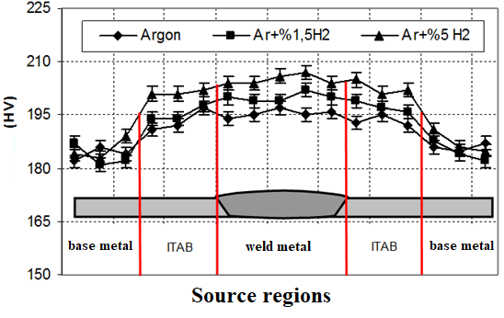

Figure 4.1. Hardness measurement results.

4.2. NOTCH IMPACT EXPERIMENT

Notch impact test results of 1.5x10x55 mm prepared from weld metal and base metal of welded samples joined in three different shielding gas environments are given in Figure 4.2. Notch impact tests were carried out only to compare the base metal welded and welded samples with each other (to determine the effects of H2 gas added to the argon shielding gas).
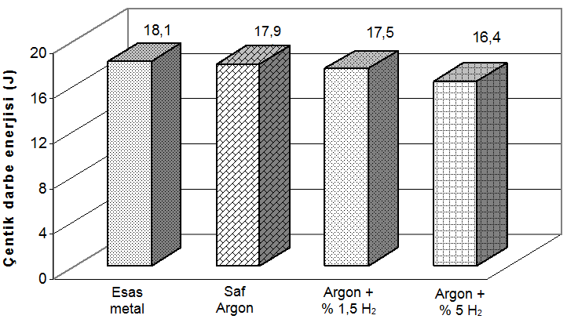

Figure 4.2. Notch impact test results of base metal and butt welded specimens.
When Figure 4.2 is examined, it is seen that the highest notch impact strength was measured from the base metal with 18.1 J. When the notch impact strength of the weld metals of the welded samples joined in three different shielding gas environments is examined, the highest value was obtained with 17.9 J from the samples combined in the pure argon shielding gas environment. This sample is followed by argon + 1.5% H2 with 17.5 J and argon + 5% H2 with 16.4 J. From this, it is concluded that the H2 gas added to the argon shielding gas reduces the notch impact toughness. In addition, it was determined that the toughness decreased with the increase of the amount of H2 added to the argon gas. When argon+H2 gas was used, the heat input to the weld area increased and the amount of δ-ferrite in the weld area increased with high heat input. The increase in the amount of δ-ferrite with a volume-centered cubic structure in the weld metal also caused a decrease in the notch impact values. A previous study also supports this result [33].

4.3. FAILURE EXPERIMENT

Wohler curves obtained as a result of bending fatigue tests were drawn by marking the number of cycles against the highest stress. For comparison purposes, samples were prepared for each gas mixture in the butt and overlap welded connections. The dimensions of the butt weld samples in Figure 4.9 and the lap weld samples in accordance with EN 288-3 are given in Figure 4.10. The experiments were carried out at room temperature in the fatigue machine photographed in Figure 4.11. The test samples are in seven groups and their properties are given in Table 6.1.
Table 4.1. Sample group and properties.
NO. | Welding Form | Gas Composition | Current Intensity
1 | Unsourced | ------------- | -----------
2 | Forehead | pure argon | 80 amps
3 | Forehead | Argon + 1.5% H2 | 70 amps
4 | Forehead | Argon + 5% H2 | 60 amps
5 | Mounting | pure argon | 80 amps
6 | Mounting | Argon + 1.5% H2 | 70 amps
7 | Mounting | Argon + 5% H2 | 60 amps

In Figure 4.3, the fatigue strength of the base material and the fatigue strength of the butt-welded specimens in a pure argon gas atmosphere are compared. It has been observed that the fatigue strength of the specimens welded in a pure argon atmosphere, which are exposed to heat during welding and have deformations in their structure, are naturally lower.

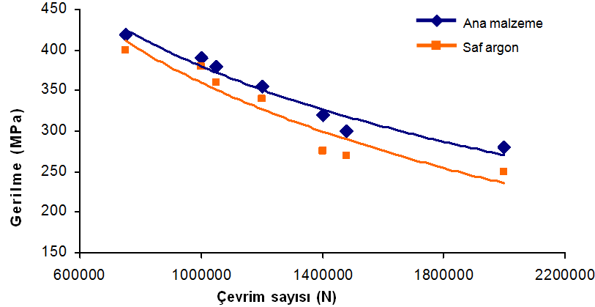

Figure 4.3. Fatigue strength of butt welded specimens and base material in pure argon atmosphere.

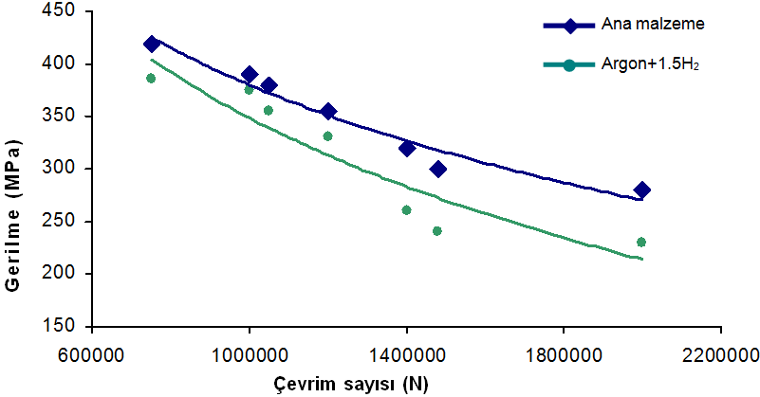

Figure 4.4. Fatigue strength of butt-welded samples using base material and argon + 1.5% H2 gas.
In Figure 4.4, the fatigue strength of the base material was found to be higher when the fatigue strength of the base material was compared with the fatigue strength of the samples welded to the buttock in argon + 1.5% H2 atmosphere.
In the literature, it is stated that the hydrogen remaining in the molten weld metal is trapped in the weld metal and HAZ as the weld seam cools and causes cracks in time, especially in the transition zone. Since the emitted hydrogen collects in the triaxial stress regions (at the spikes of dislocations and microcracks), increases the stress there and forces crack propagation, the fatigue strength decreases with the increase of its addition to the shielding gas [19].
The phenomenon that occurs as a result of the joint effect of the changing stresses and the corrosive environment is called corrosion fatigue. In this case, if a suAUHIle surface protection is not foreseen, a significant decrease in fatigue strength is observed.
Stress-free pre-corrosion occurs when the corrosion event and the fatigue stress follow each other at different times. The severity of the damage in stress-free pre-corrosion depends on the pre-corrosion time and the corrosion environment.
The phenomenon that occurs as a result of the joint effect of the changing stresses and the corrosive environment is called corrosion fatigue. In this case, if a suAUHIle surface protection is not foreseen, a significant decrease in fatigue strength is observed [41].
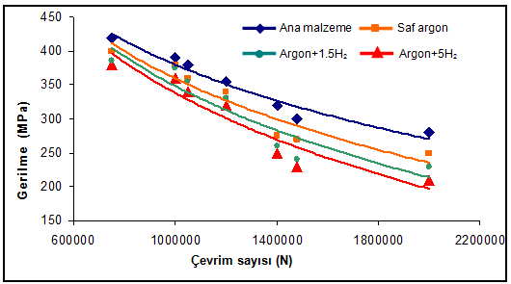
يجب أن تكون المسافات والنصوص الأنيقة في تباعد سطر واحد ، ويجب أن يكون النص الأنيق فقط في النهاية بأقواس مغلقة.
إذا كان الشكل يتكون من عدة أجزاء ، فيمكن عرضه بطريقتين مختلفتين. يجب فحص الأمثلة في الشكل 6.5 والشكل 6.11.

a) butt welded

Figure 4.5. Comparison of fatigue strength of samples with base material and three different gas atmospheres (pure argon, argon +1.5% H2 and argon + 5% H2).
إذا كانت هناك مسافات بيضاء إضافية أعلى أو أسفل الشكل ، فيجب أن يكون الشكل مؤطرًا ويجب ألا تُرى المسافات كثيرًا.
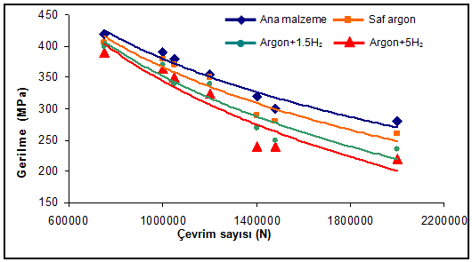
إذا كان الشكل أو الجدول لا يتناسب مع صفحة واحدة، فيجب كتابة الشكل أو الرسم البياني بأكمله في أسفل الصفحة الأولى ، وفي نهاية القسم التالي في الصفحة أو الصفحات الأخرى (تابع). يجب إضافة العبارة.

b) lap welded

Figure 4.5. (continues).

4.4. MICROSTRUCTURAL STUDIES

In Figure 4.6, the microstructure images of the sample, which were joined face to face under pure argon shielding gas, are given. Here (a) and (b) HAB show the fusion boundary and weld zones including the weld metal, while (c) and (d) show the weld metal microstructures at two different magnifications. In Figure 4.6 (a) and (b), it is seen that the surface of the molten-solidified zone (weld metal) and the fusion boundary and HAZ have a quite different appearance from each other. In HAZ, it is seen that grain coarsening occurs due to high temperature and there is a regular transition from base metal to weld metal.
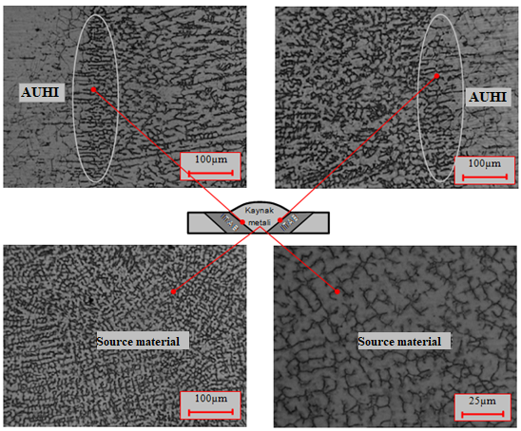
يجب أن تكون المسافات والنص الأنيق في تباعد سطر واحد، ويجب إعطاء الخيارات بأقواس مفتوحة على اليسار وأقواس مغلقة على اليمين.
(a) (b)

(c) (d)

Figure 4.6. Microstructure image of the sample combined under pure argon shielding gas. a) and b) transition zone, c) and d) weld metal microstructures at two different magnifications.
في تدوين النوع الثاني ، يجب تقديم تفسيرات الخيارات فقط بين قوسين مغلقين من اليمين في الشكل أو نص الجدول.

Chapter 5
يكون اسم الفصل بخط نوع SimSun وبحجم 18 من نوع Bold
يكون عنوان الفصل بخط نوع Times New Roman وبحجم 12 من نوع Bold

RESULTS

In this study, AISI 304 (X5CrNi1810) type austenitic stainless steel sheet materials were joined by TIG welding method under three different shielding gas compositions (pure argon, argon+1.5%H2 and argon+5%H2). Tensile, bending, notch impact and fatigue tests were applied to the welded joints to determine their strength. In addition, hardness and optical microscopy studies of the welded samples were carried out in the weld areas. As a result of this study, in which austenitic stainless steels are joined by TIG welding method and the effect of shielding gas on mechanical properties;
      - According to the hardness test results, the highest hardness values were measured from the weld metal in all shielding gas environments, followed by AUHI and base material, respectively.

      - When the hardness test results are evaluated in general; It was determined that there was a decrease in hardness from the weld zone towards the base metal.

      - After the tensile test, both the butt joints and the lap joints rupture occurred at AUHI. These results show that weld seams are safe.

      - According to the tensile test results of welded joints made using different shielding gas, the lowest tensile strength was obtained under pure argon gas protection, while the highest tensile strength was obtained from the welded sample performed under Ar + 1.5% H2 gas protection.
      - According to the % elongation results obtained as a result of the tensile test, higher values were obtained than the base material in the joints performed with argon and Ar + 1.5% H2 shielding gas in the butt joints. A lower % elongation value than the base material was determined in Ar+% 5H2 butt joint and in all lap joints.

      - As a result of the bending test up to 180o, no cracks, tears, etc. were found in any of the welded samples in the visual examination. no error was found.

      - According to the notch impact test results made to compare the welded samples and welded samples with the base metal only, it was determined that the toughness values measured from all of the welded samples were lower than the base metal. In addition, it was determined that H2 gas added to argon reduces the notch impact values.

REFERENCES
- يجب كتابة قسم المراجع ، على عكس الأطروحة بأكملها ، بمسافة سطر واحد ومسافة فقرة واحدة بينهما.
- تحتوي المراجع أدناه على أمثلة لجميع أنواع المراجع التي قد تحتاجها في أطروحتك.
- أهم قضية يجب الانتباه إليها أثناء كتابة المصادر.
- كحد أدنى ، يجب أن يحتوي كل مصدر على المعلومات المكتوبة في أمثلة المصدر أدناه. يجب البحث عن هذه المعلومات وإضافتها إلى المصدر. لا يهم كيف كتبت من أين حصلت عليها. الشيء المهم هو أن تكتب وفقًا لقواعد كتابة أطروحة FBE.
- إذا كنت قد قدمت المراجع بالترتيب الأبجدي ، يمكنك أن ترى كيف سيتم إنشاء قسم "المراجع" في التفسيرات الإضافية "ب".
- يجب كتابة كل مرجع بدءًا من السطر الأول بدءًا من السطر الثاني. (إذا استخدمت الترقيم التلقائي ، فتأكد من أن الأرقام تبدأ بمسافة 4 سم من اليسار ، وليس بها مسافة بادئة).
- انظر أسفل الصفحة لكتابة كل مصدر.
مثال المادة

مثال المادة
مثال فصل الكتاب
مثال على ملاحظة المحاضرة
- Anil, K. S., “Dynamic strain ageing of various of steels”, Metallurgical Transactions A, 13 (A): 1793-1798 (1982).

- Goto, S., Levec, J. and Smith, J. M., “Mass transfer in packed ebds with twophase flow”, Ind. Eng. Chem. Process Des. Dev., 14 (2): 473-485 (1975).

- Goto, S., Levec, J. and Smith, J. M., “Mass transfer in packed ebds with twophase flow”, Heat Transmission 2nd ed., Mc Graw Hill, New York, 278-292 (1942).

- Mc Adams, W. H., “Heat Transmission 2nd ed.”, Çeviri Editörü/Editörleri, Mc Graw Hill, New York, 278- 292 (1942).
عينة كتاب

- Tosun, A., “Yaşlandırılan çift fazlı çeliklerin mekanik davranışlarının incelenmesi”, Yüksek Lisans Tezi, Zonguldak Karaelmas Üniversitesi Fen Bilimleri Enstitüsü, Zonguldak, 30-40 (2007).
مثال على أطروحة
MSc / DR

- Gedik, E., “Akışkanlar Mekaniği I Ders Notları”, Karabük Üniversitesi Makine Mühendisliği Bölümü, Karabük (2015).

- Toppare, L., “Elektrokimyasal yöntemle 4-bromstrien ile α-metilstirenin kopolimerleşmesi”, II. Ulusal Makromolekül Sempozyumu, İzmir, 85-96 (1985).
عينة ورقية

- Baran, I. and Kasparek, M., “Marine turtles of Turkey; Status survey 1988 and recommendations for conversation and management”, WWF Report, Heidelberg, 123-130 (1989).
تقرير / مثال على براءات الاختراع

- İnternet: Türkiye İstatistik Kurumu, “2004 Belediye Atıksu İstatistikleri”, http://www.tuik.gov.tr/PreHaberBultenleri.do?id=416 (2004).
مثال الإنترنت

- Mc Adams, W. H., “Heat Transmission 2nd ed.”, Mc Graw Hill, New York, 278- 292, 301-308, 615-621, 688-690 (1942).
• يجب كتابة المؤلفين بتنسيق اللقب ، والاسم الأول (الأسماء) ، مع مسافات بينهما ، إذا كان عدد المؤلفين 2 أو أكثر ، يجب كتابة "و" أو "و" بين المؤلف الأخير والمؤلف السابق حسب لغة المصدر. (في حالة عدم وجود مؤلف ، يجب كتابة اسم المؤسسة التي نشأ منها المصدر).
• أثناء كتابة علامات التنصيص. إذا لم يكن كتابًا مرجعيًا أو ملاحظة محاضرة أو إنترنت ، فيجب كتابة الحرف الأول من الكلمة الأولى بأحرف كبيرة ، ويجب كتابة جميع الكلمات الأخرى بأحرف صغيرة (باستثناء الأسماء المناسبة) ، وإلا يجب كتابة الحرف الأول من كل الكلمات بحروف كبيرة .
• إذا كان المصدر عبارة عن أطروحة ، فيجب إضافة نوع الرسالة (رسالة ماجستير أو رسالة دكتوراه). للأطروحات الأجنبية ماجستير. أطروحة أو دكتوراه. يجب استخدام د. الرسالة
• يجب كتابة مكان المنشأ (مجلة ، مؤسسة ، إلخ) بخط مائل غامق ، ويجب كتابة الحرف الأول من كل كلمة بحروف كبيرة.
• يجب إضافة معلومات المدينة والبلد في المجلات والموارد غير المتصلة بالإنترنت. (المدينة ، الدولة التي يوجد بها الناشر للكتب).
• إذا كان المصدر عبارة عن مقال ، فيجب كتابة حجم المقالة ورقمها ونطاق صفحاتها بالتنسيق رقم المجلد (رقم العدد): تباعد الصفحات مع مسافات بينها. في أنواع المصادر الأخرى ، يجب إعطاء نطاقات الصفحات المستخدمة.
• يجب كتابة جزء السنة فقط على أنه السنة بين قوسين لجميع أنواع الموارد. يجب عدم وضع الفاصلة قبل القوس.
• عند كتابة موارد الإنترنت ، يجب كتابة عنوان البيانات بالكامل بالخط العريض والأسود (وليس بالخط المائل). (احرص على عدم استخدام ويكيبيديا ومواقع المدونات وما إلى ذلك في إطار القواعد الأكاديمية.)
عينة كتاب

APPENDICES

في هذا الجدول في قسم الملحقات يتم ادراج المواد التي استخدمها الطالب في البحث وكما موضح بالمثال ادناه
جدول رقم (1) المواد المستخدمة في التجارب

ت | المادة المستخدمة
1 | ماء مقطر
2 | حامض الكبريتيك H₂SO₄
3 | هدروكسيد الامونيوم NH₄OH
4 | بروتين Protien

في هذا الجدول في قسم الملحقات يتم ادراجالاجهزة المختبرية التي استخدمها الطالب في البحث وكما موضح بالمثال ادناه

جدول رقم (2) الأجهزة المستخدمة بالتجارب

ت | اسم الجهاز | المنشا | الشركة
1 | حاضنة incubater | كوريا | Labtach
2 | ثلاجة Refrigerator | تركيا | Kebo
3 | جهاز المطياف الضوئي Spectrphotometer | اليابان | Apple

